**How these social robots are helping autistic kids**

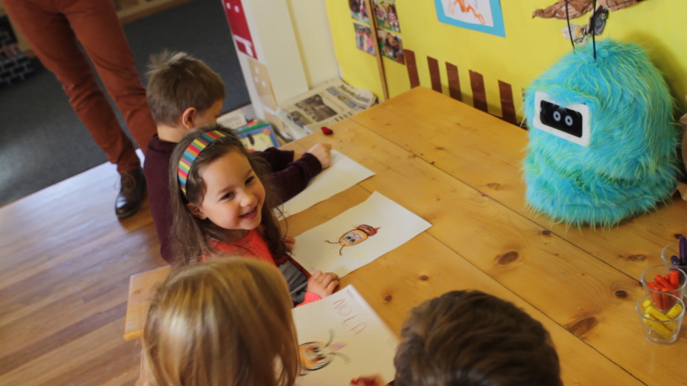[Christina Farr](http://venturebeat.com/author/christina-farr/) March 8, 2014

Above: Children playing with a Romibo robot

*Image Credit: Romibo*

At the Duck’s Nest preschool in Oakland, Calif., a fluffy blue robot asks a group of toddlers, “I want to be your friend. Will you please be my friend?”

Robotics experts are testing this low-cost and affable robot, called [Romibo](http://www.romibo.org/), at schools across the country. According to its creator, Aubrey Shick, special-needs children can benefit most from social robots like Romibo — particularly those with autism.

[Indeed, behavioral experts](http://blogs.du.edu/magazine/academics-research/tech-savvy-research-team-aims-to-help-kids-with-autism-disorders) say that human facial features can overwhelm those with an autism spectrum disorder (ASD). [Researchers at Vanderbilt University](http://news.vanderbilt.edu/2013/03/robot-helps-children-with-autism/) found that autistic children are more comfortable looking at a robot than a human therapist.

“The robot is safe. The robot’s facial features don’t change,” says Laura McGuire, the mother of Liam, an autistic child.

“There’s not so much to figure out with talking to a robot, where there was a lot to figure out in talking to a human being.”

[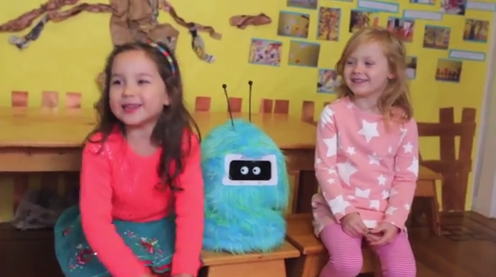](http://1u88jj3r4db2x4txp44yqfj1.wpengine.netdna-cdn.com/wp-content/uploads/2014/03/screen-shot-2014-03-04-at-11-48-38-am.png)

Above: The Romibo “social robot”

[Recent studies have shown](http://online.wsj.com/news/articles/SB10001424127887324582004578456681984219240) that social robots [provide therapy](http://www.technologyreview.com/view/521746/how-social-robotics-is-revolutionising-therapy-for-autistic-children/) (or co-therapy, in combination with the efforts of a human expert) and potentially even help teach autistic children new skills.

And when used in a clinical setting, these talking robots may even help diagnose autism earlier. Most autistic children aren’t diagnosed with the disease until they are at least 3 years old. But studying eye movement in high-risk babies (those with an autistic family member) can lead to an earlier diagnosis. A sophisticated social robot with cameras for eyes could study such movement in an infant over periods of time to detect signs of autism.

In 2013, interest in social robotics grew when the [University of Notre Dame published results](http://news.nd.edu/news/15169/) from a study of 19 children with autism, which may be the largest trial to date for this technology. The researchers purchased a $14,000 talking robot, nicknamed Kelly, to coach autistic children to make eye contact or take turns talking. Kelly is a Nao “humanoid” robot, developed by French parent company [Aldebaran](http://www.aldebaran-robotics.com/en/) in collaboration with eight universities and robotics companies in the U.K., France, Switzerland, Greece, and Denmark.

The results were promising: Social robots do seem to help autistic children.

**Social robotics for the mass market**

The challenge to mass-market adoption, however, is price. Most of these smart robots do not come cheap.

Since the 1990s, the field has attracted a great deal of attention from university professors armed with ample grant money. Funding for research has increased in the past decade, with autism labelled a public health “[epidemic](http://blogs.discovermagazine.com/crux/2012/07/11/is-autism-an-epidemic-or-are-we-just-noticing-more-people-who-have-it/)” in the press. A frequently cited 2013 report from the U.S. Department of Health and Human Services and the U.S. Centers for Disease Control and Prevention found that 1 in 50 children between the ages of 6 and 17 have been diagnosed with an autism spectrum disorder. This represents a more than 70 percent jump in the diagnosis since 2007.

In recent years, the space has finally opened up to lower-budget researchers and hardware entrepreneurs, who are raising money for their early prototypes on crowdfunding sites. Social robotics is no longer an obscure area of research — it’s now a viable business opportunity.

“It’s a prime example of what becomes possible with the new hardware ecosystem,” said Matt Turck, the managing director at New York-based venture firm [First Mark Capital](http://firstmarkcap.com/). “You can build a niche solution like this at low cost using a cheap, versatile computer like the Raspberry Pi, and through crowdfunding, you can get it funded by people who care passionately about the issue.”

While the Kelly robot used in the Notre Dame study cost thousands of dollars, Shick intends to sell Romibo for a few hundred dollars. Later this year, she’ll launch a campaign to raise funds on [Kickstarter](http://kickstarter.com) or [Indiegogo](http://indiegogo.com).

“Finally, we’re developing low-cost robots and putting them into people’s hands,” she said. “These robots are now affordable for researchers with less of a budget, [as well as for] schools and families.”

[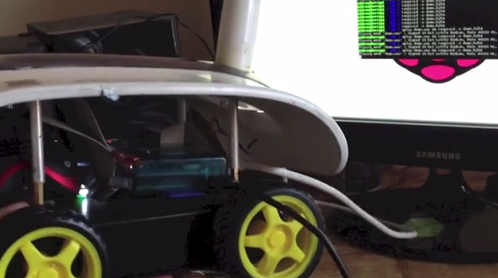](http://1u88jj3r4db2x4txp44yqfj1.wpengine.netdna-cdn.com/wp-content/uploads/2014/03/screen-shot-2014-03-05-at-2-37-30-pm.png)

Above: The One is designed to gather data

In Boulder, Colo., another team is building its own low-cost robot for children with special needs. The founders of Robauto are [raising funds](https://www.kickstarter.com/projects/jhartman/one-a-low-cost-autism-companion-and-teaching-robot) on Kickstarter for a new social robot they call One (the company has already raised $50,000 from the [Healthbox](http://healthbox.com) startup accelerator and others). Developer kits cost just shy of $150, and the One robot is both customizable and portable. It runs off the Rasberry Pi micro-computer and is designed to gather data about autism.

The One Kickstarter campaign is trudging along slowly. It has raised a little more than $4,000 of a $50,000 goal with a week to go. The campaign may struggle to connect with potential buyers as the One isn’t particularly cuddly or human-like. It’s not nearly adorable as the Romibo, which resembles a 21st-century Furby.

Still, Robauto’s founders are convinced that One will find its market, if only because it’s one of the most affordable options.

“Cost was a big hindrance for social robotics,” said company spokesperson Jalali Hartman. “So we set out to bring the costs down to less than [the cost of] an iPad.”

**Can these robots replace human therapists?**

Romibo, One, and the slew of other new social robots are inexpensive, in part because they do not incorporate artificial intelligence.

Shick said it was an intentional choice to steer clear of A.I. She doesn’t subscribe to the school of thought that a robot should [replace or fill in](http://sfari.org/news-and-opinion/toolbox/2013/robots-could-fill-in-for-autism-therapists) for a therapist or exhibit human-like sentiment. Rather, Romibo is designed to be an assistive device for a behavioral expert or teacher. Shick’s goal is to use technology to promote social behavior, not just to have the child solely engage with the device.

Other scientists believe that the most successful robots are smart enough to interact with a child. Kelly incorporates A.I. and is capable of developing and displaying emotion. Like other Nao robots, Kelly can also walk, talk, and dance. When the kids succeed, the robot can even give them in a celebratory high-five.

[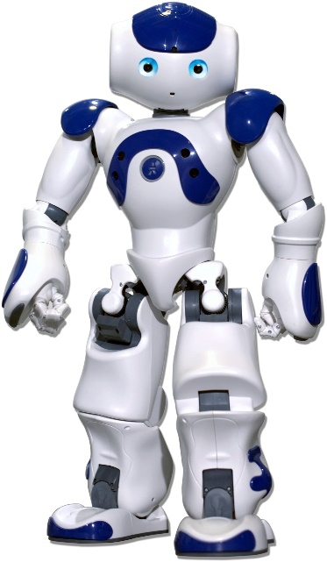](http://1u88jj3r4db2x4txp44yqfj1.wpengine.netdna-cdn.com/wp-content/uploads/2014/03/nao-robot.jpg)

Above: The Nao robot

Questions remain about the type of robot that will have long-term success with an autistic child. It’s still too early to know whether special needs children will respond better to simpler robots like Romibo or a more sophisticated device [like the 23-inch-tall Nao](http://www.aldebaran-robotics.com/en/). It’s also not yet clear why some children respond to social robots and others do not and how well the learned skills translate to the real world.

“What we’re all hoping to do is present the theory and procedure for how to effectively use the robot in the field — no background or research expertise needed,” said Shick.

“We’re finally leveraging these robots for the mass market to really make a difference.”

*Don’t miss the video below to see how preschool children engage with the Romibo.*

[Reblog this post [with Zemanta]](http://reblog.zemanta.com/zemified/348ef1d5-4fa9-477e-92c2-13bceabdaebb/)

**More information:**

* [Kickstarter](http://venturebeat.com/2014/03/08/how-these-social-robots-are-helping-autistic-kids/#company-4fea97bd3ae4b213de004df8)
* [IndieGogo](http://venturebeat.com/2014/03/08/how-these-social-robots-are-helping-autistic-kids/#company-521b35d6843bac6772000fa3)

Kickstarter is an online platform for funding creative projects. Once a project is approved by the Kickstarter team, the creator of the project must set their own goal for how much they would like to raise and a deadline to raise the m... [read more »](http://www.vbprofiles.com/companies/4fea97bd3ae4b213de004df8)

**Robo therapy**

A new class of robots provides social and cognitive support.

By Kirsten Weir

June 2015, Vol 46, No. 6



It sounds like a game, but this so-called "bubblebot" is an important early step in the budding field of socially assistive robotics. The bubblebot was designed to help children with autism develop social skills, but the possibilities for therapeutic robots don't end there. Socially assistive robots could provide companionship to lonely seniors, teach coping skills to adolescents with depression or even help someone quit smoking or lose weight.

Robot therapy isn't as out there as it sounds. For decades, robotic systems have helped provide physical therapy, says ***Brian Scassellati, PhD, a social robotics researcher at Yale University***. Recovering stroke victims, for instance, have used a robotic system to help guide their limb movements during physical rehabilitation exercises. "Socially assistive robots don't offer physical support, but rather cognitive or social support," he says. "Anytime you could use a good personal coach or trainer, we're starting to see robots involved in that kind of application."

The goal isn't merely to provide kids with a robotic playmate. Rather, researchers hope that robotic systems can help the children learn valuable social skills such as imitation, taking turns and maintaining joint attention with another person. "The ideal is that the robot is a peer. It ***encourages*** the child to exercise those social behaviors that the child otherwise couldn't or wouldn't do," says Maja Mataric, PhD, a robotics researcher at the University of Southern California who developed the bubblebot with her then-graduate student David Feil-Seifer, PhD, now a robotics researcher at the University of Nevada, Reno.

***The ultimate objective***, of course, is that the child would extend those behaviors to his or her interactions with other people. And there's evidence that happens. As Scassellati and Mataric describe in a recent review, a variety of studies have reported that kids with autism will look from the robot to a parent and back again, or excitedly point out some feature of the robot to an adult or another child (*Annual Review of Biomedical Engineering*, 2012). In their excitement, the children seem to naturally seek out those joint displays of attention that are so important for social interaction.

* *Maja Mataric, PhD, a robotics researcher at the University of Southern California describes one child with autism who engaged with the bubblebot. The boy tried to tell the robot what to do, but became frustrated when the robot was unable to follow his instructions. "Then he said, ‘This is how my teacher feels when I don't do what the teacher says,'" she recalls. "This was an incredible narrative of empathy that the therapist was just jumping up and down about."*

**Robots for behavior change**

The research on socially assistive robots for children with autism is still at an early stage, and the devices aren't yet being used therapeutically. But robotic devices are being used to provide companionship to older adults in some hospitals and nursing homes. One of the most widely used is Paro, a furry robot designed to look like a baby harp seal.

Developed by Japanese scientists, Paro coos and wiggles in response to being petted or spoken to. It blinks when the lights go on, turns toward sounds and responds to its name. And it appears to be a comfort. The $5,000 plush seal has been reported to reduce stress and stimulate social interactions between a patient and his or her caregivers and peers. Some reports also suggest that Paro helps reduce problematic behaviors, such as wandering and agitation, in patients with dementia.

Yet the quality of research varies widely. A 2009 review by Dutch researchers concluded that robots such as Paro do seem to have positive benefits for older adults, in areas such as reduced stress and loneliness, improved mood and increased social connections. However, the reviewers noted, the methodology behind the studies was often lacking. More work is needed for robust evidence of the robots' benefits, they concluded (*Gerontechnology*, 2009).

Part of the problem, says Mataric, is that robotics research is expensive, and funding has been hard to come by. "We can barely get funds to pay for one or two robots and recruit a handful of families," she says. Without adequate support, she says, it's impossible to design studies large enough to generate statistically significant findings. That may be starting to change, however, as federal funding sources such as the National Science Foundation are [beginning to support](http://www.apa.org/science/about/psa/2014/05/team-up-congress.aspx) socially assistive robotics projects.

Yale psychologist Alan Kazdin, PhD, agrees that stronger evidence is needed to confirm the therapeutic benefit of these robots. Nevertheless, he sees potential in the field of socially assistive robotics. He's recently begun studying Paro, trying to understand at a basic level which facets of the robotic interaction might reduce stress in children. But he envisions broad uses for socially assistive robotics, far beyond mechanical seals. A robot could, for example, nudge a child to practice the violin, or urge someone trying to lose weight to lace up those gym shoes. "Anywhere there is behavior change, there might be a role for robots," he says. "The key to behavior change is practice, and practice with feedback is always better."

Yet most important, in Kazdin's view, is the potential for robots to help address untreated mental illness. "About 70 percent of people in need of psychiatric services in the U.S. receive nothing," he says. "What can we do to help reduce the burden of mental illness?" He wants every option on the table, whether that's smartphone apps, self-help programs, online therapy or, yes, robots.

Individual psychotherapy is excellent for the people who have access to it, Kazdin says. But there simply aren't enough providers to reach everyone who needs help. If a robot could help alleviate anxiety or depression, why not?

For now, though, robotics researchers think of their creations as tools, not substitutes. "No one thinks these things are going to replace teachers or therapists," Scassellati says. "We think the real benefit is increased one-on-one tutoring time, and we're drawn to these domains where there's just not enough human support to cover the need."

**Tailor-made technology**

Robots may offer certain advantages that other technology does not. "With a physical robot, you learn much faster than you would from a character on a screen," Scassellati says. People are also more compliant when a robot asks them to do something.

In one amusing illustration of this tendency, Scassellati and colleagues used a robot to direct volunteers to shelve books in an office — and put a pile of new textbooks in the trashcan. Half of the participants received instructions from a robot that was in the room with them, while the rest took orders from the same robot broadcast in real time on a video screen (*International Journal of Social Robotics*, 2010). "With the real robot, more than 70 percent of people threw the books away, no questions asked. With the same robot making the same gestures but on [video], only about 20 percent did it," he says. "When we're asking people to do something hard, we want that leverage."

Still, researchers have a lot of questions to sort out before we welcome a fleet of social robots into our daily lives. Any kind of behavior change takes time, and robots need to be pretty sophisticated to hold a person's interest over the long term. "We know how to build things that are durable enough and expressive enough," Scassellati says. "The challenge is in terms of putting enough intelligence into a robot so it can really be engaging and motivating over a period of weeks or months."

It's hard enough for a person to understand what makes another person tick. But robotics developers need to tell a machine how to figure out what's going on in a person's head — and then respond accordingly. That's an enormous challenge, says Feil-Seifer.

Social cues can be subtle, but it's important that socially assistive robots give and receive such cues in ways that are both expected and helpful. While working with the bubblebot, for instance, Feil-Seifer realized that the robot would take the most efficient path when moving across the room. But a child could easily feel snubbed by a robot zipping away. To counteract that, he programmed in pauses in which the robot would stop and wait for the child to catch up. "That's a nice social cue that the robot was trying to maintain connection," he says. "Interaction is fragile and we don't ever want to break that."

Another issue is determining what physical form the robot should take. Is a fluffy seal the best choice? A cartoonish dragon? A humanoid with a friendly face? "There's not one form that's right for everything we want to do. A robot that helps a child learn social skills will probably look different from one that helps a 40-year-old quit smoking," Scassellati says.

Yet while such questions are important, Mataric adds, the field won't move forward if researchers get hung up on every detail. Though it may be uncomfortable for scientists to accept, she says, traditional research that tries to look at each element of human-robot interaction one at a time is all but impossible. "Human social interaction is incredibly rich, and we can't control all these factors," she says.

She thinks of socially assistive robots as a kind of personalized behavioral health care. "I really think we're doing a disservice to people with special needs when we are seeking solutions for everybody," she says. With 3-D printing and similar fast-evolving technologies, kids will soon be able to design their own robots, she says. "I don't want to worry about whether an oval head or round head is best. Who cares if it has seven ears, if it works for the kid?"

Robot behavior, too, could be customized. While working with children with autism in Mataric's lab, Feil-Seifer saw that some responded well to the robot while others did not. He developed a computer program that recognized within two seconds whether or not the child was having a positive interaction. This kind of early-detection system could be used in the future to turn any number of robot features on or off depending on how a person responds to them.

As robotics researchers continue to develop new and better systems for socially assistive robots, psychologists can offer important insight into the complexities of human behavior. "Technologists, psychologists, neuroscientists: We all have to shed the arrogance of our own specific field and work together," says Mataric. "It's way too soon to make any conclusions, but it is absolutely time to invest in really developing these technologies to see how they can complement human care — because the need is huge."

*Kirsten Weir is a writer in Minneapolis.*